Project Design Phase
Solution Architecture
Date | 9 September 2026
Student Name | Burada Laxmi Sai Priyanka
Project Name | Licensed Software Installation Request through Service Catalog
Maximum Marks

Solution Architecture
The architecture connects the Service Portal, Licensed Software Request Catalog, validation rules, license availability checks, approval process, and software fulfillment tasks to manage employee software installation requests efficiently.

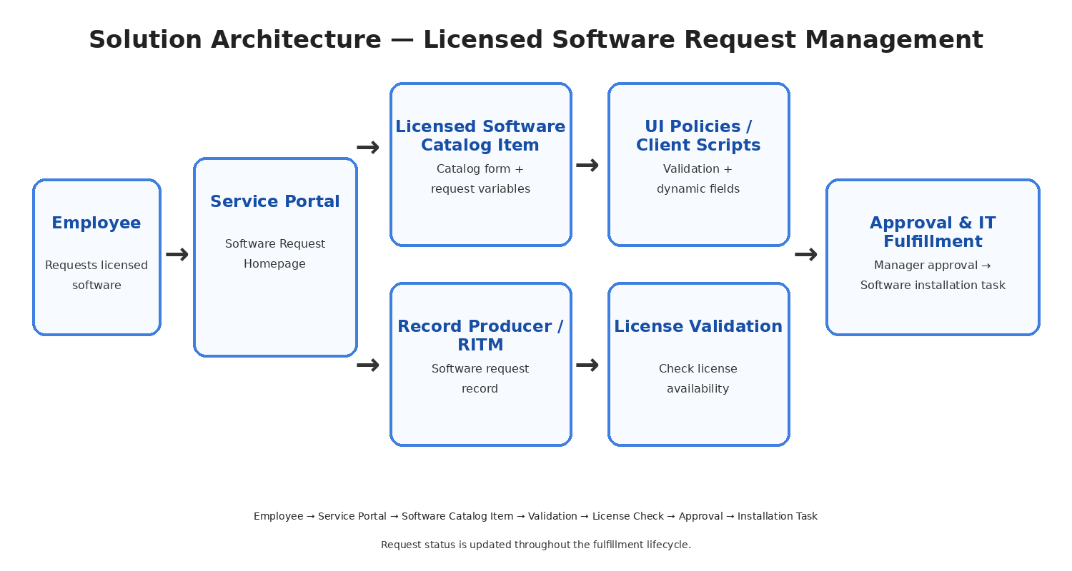
Figure 1: Solution architecture for the Licensed Software Installation Request project.

Layer | Components | Responsibility
Experience | Service Portal, Software Request Catalog | Employee request interface for accessing and submitting licensed software requests.
Interaction | Catalog Client Scripts, UI Policies, Catalog Actions | Controls form behavior, validates inputs, and shows or hides fields dynamically.
Catalog | Licensed Software Catalog Item | Collects software name, version, business justification, device, and installation details.
Rules | Catalog UI Policies, Client Scripts, License Validation | Validates request data, controls dependent choices, and checks license availability.
Automation | Flow Designer, Approvals, Notifications | Routes approvals, creates fulfillment tasks, sends notifications, and updates request status.
Data | REQ, RITM, Software Request, Fulfillment Task | Stores employee requests, requested items, license checks, approvals, and installation records.
References | sys_user, sys_user_group, Software/License records | Provides employee, approver, fulfillment group, and licensed software reference data.

